NOTES FROM MICHEL GARCIA INDIGO WORKSHOP
By Deb Donnelly
January 2 2012 Hong Kong
debdonnelly@xtra.co.nz
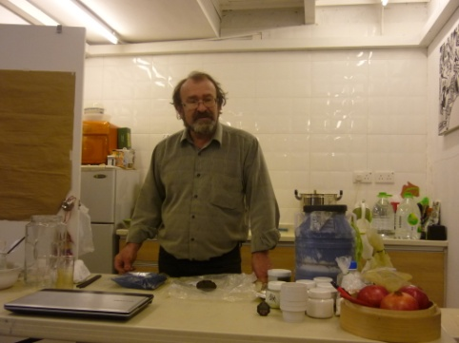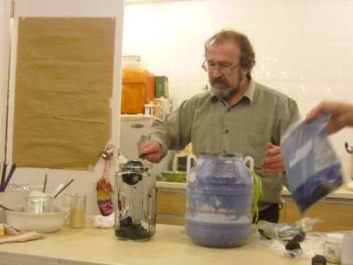
Michel Garcia, botanist, chemist, dyer and naturalist at Hong Kong Shibori Symposium Natural Dye workshop
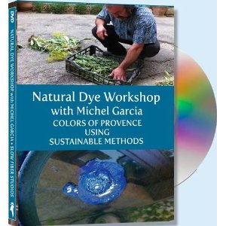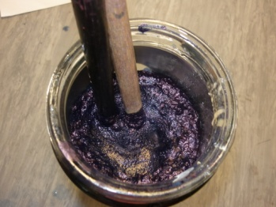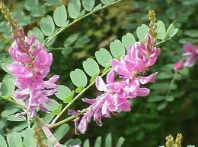

INTRODUCTION
INDIGO PLANT AND EXTRACTION.
Indigo was found 5000 years ago in Indus.
In India the use of vegetable dyes dates back to the Indus Valley period between the 4th and 2nd centuries BC. References were made by explorer Marco Polo who saw indigo at present day Quilon in the state of Kerala in 1298. (kew.org/plant-cultures/plants/indigo_history.html)
To extract the indigo dye (Persica tinctoria) as in France and Japan (a compost technique on indigo leaves known to make sukumo - composted leaves is used. Leaves are watered every 5 days to start the decomposing and fermentation process. It takes usually 100 days to complete fermentation. This forms the basis for the indigo dye which is called "sukumo.") Lime and water is added, mixed well for oxygenation so the pigment and sediment changes the PH value so that the vat water can be safely returned to the fields.
Indigo dye extraction from leaves i.e.maceration-oxygenation-filtration then the dye extract is dried outdoors before crushing to powder form.

VAT DRAWING – FERMENTATION PROCESS
Oxygen must be removed from the matter. Generate bubbles/foam from insolvent indigo to make a useable amount for dyeing.
Making a paste – to make a quick indigo vat takes a couple of days.
To which a base (alkali) is added e.g. potassium, carbonate, Ca (OH)2 lime, lye, ammonia. Mix with a reducing agent – anti oxidant in a tall glass jar and indigo dye matter.

Hot water is poured over and stirred from the centre – fermentation is a reducing process.
Add an anti oxidant i.e. replace zinc with fructose or use pear peel/fruit syrup – fructose. All is bio degradable.
Check the PH = 9 therefore depending on the fibre use regular builders lime Ca OH 2 = quick lime.
To make Ca OH 3 Cook the lime source e.g. oyster shells – Ghizou method or HK Western method.
Ideal PH scale for various fibres
FIBRE | PH reference | Time frame
Silk | 10
wool | 9-10 | 15- 30 mins
cotton | 12 plus
abaca | The higher the PH the more light fast the result.
hemp | As above
ramie | As above
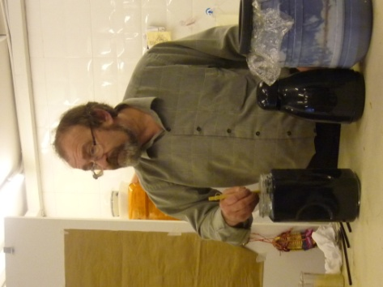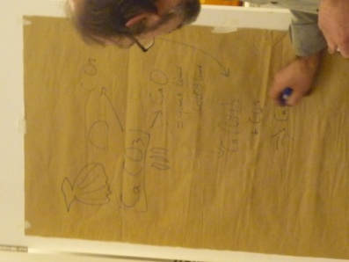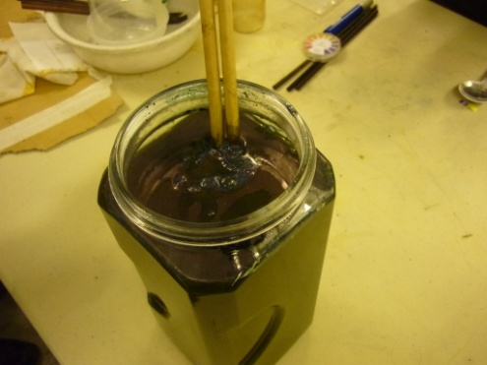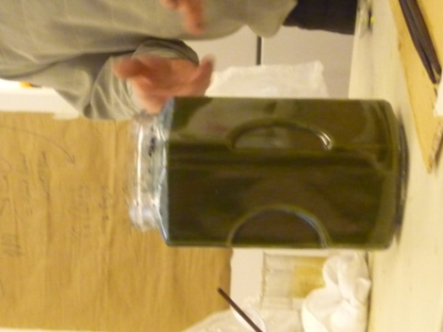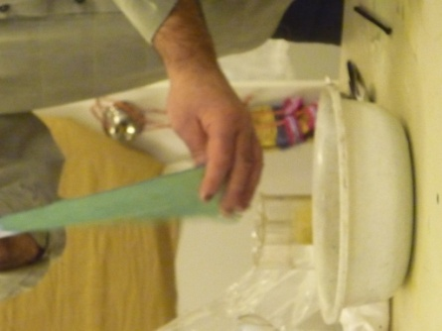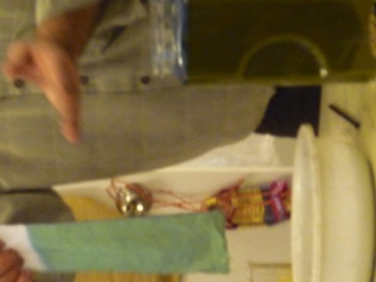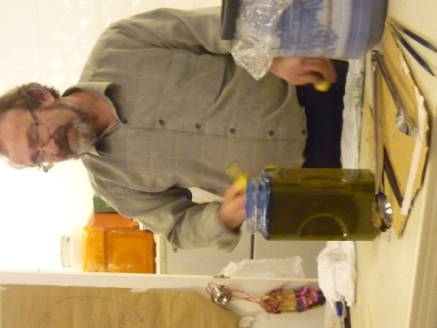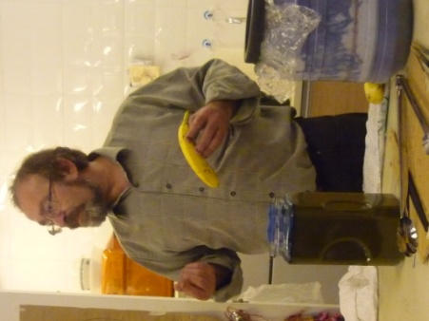
Michel demonstrates his 1-2-3 fructose test using mashed banana – you can also use pear peel, pomegranate cooked or honey but it is more expensive (prophet-of-bloom.blogspot.co.nz/2011/12/playing-blues.html?spref=fb). Redgum, ash and reject honey as the reducing agents, in an Australian variant on Michel Garcia's indigo methods. In lieu of slaked or builders lime you can use local NZ waste products including oyster shells and or garden lime products. Read commercial labels carefully for other ingredients that may effect the vat process and colour outcome.
Begin with short 20 second dips then rinse in running water.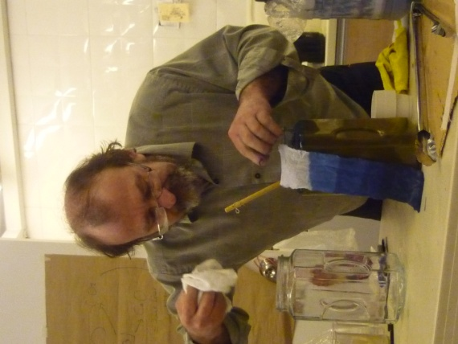
Test 1. – you can use pomegranate instead of banana or pear.
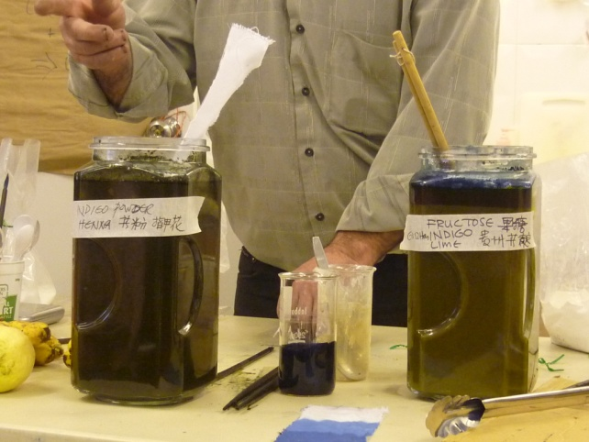
Test 2.
Powdered indigo and henna powder.
a. Prepare the indigo in a lidded container shaken well with marbles or stones. Use approx 4 tablespoons of indigo.
b. Natural henna (Lawsonia inermis composition) – 1.5 cups in a 3 litres jar, hot water.
c. Add the lime- 3 tblspoons diluted in hot water with 1 cup of ripe banana or old fruit.
Decoction – bring to boil.
Note better to do several dips for this additive process.
TIME TEMPERATURE AND PH Lime quality.

TEST 3
Fruit method – use 6 or so mashed bananas add hot water.
Use a mesh basket in a tall vat. 4 tablespoons of indigo and 3 tablespoons of Ca OH2 Lime. More interface with fibre than air is required.
TEST 4
Use extra indigo – and another henna (Indian) check the PH OF THE LIME, add sugar to make up the difference i.e. increase the PH by adding lime. Urine also includes ammonia which can act as a base reducing agent.
Questions!
- How can I keep my vat alive for a long time?
Lime is antiseptic- for efficiency add new paste with the indigo.
Check your PH according to the fabric at the start of the tests.
e.g. wool/silk PH 10/11
Create a warm vat approx 40’ C
Cotton/cellulose 12/12.5
Check the PH morning and evening take care of reduction- feed it if necessary with henna or sugar as reducing agent.

FEED THE BEAST donkey if you want it to work.
Add gelatine protein to the mix it will hold in between the alkalinity and fibre – non corrosive on wool and cellulose.
Mix lime and wood ash - potassium carbonate KCO3 +Ca OH 2 = K OH high PH.
Lime + oak + ash is the Japanese traditional mix.
- What is the difference between natural and synthetic indigo?
1 tspn of synthetic indigo = 2 tspn of indigo isomer. In chemistry, isomers are compounds with the same molecular formula but different structural formulas. (Wikipedia) Natural indigo is good for health – anti bacterial qualities ( Michel Garcia 2 Jan 2012).
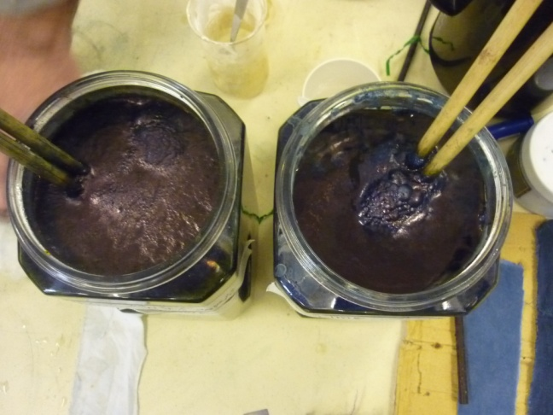
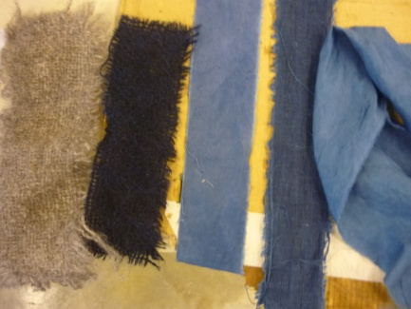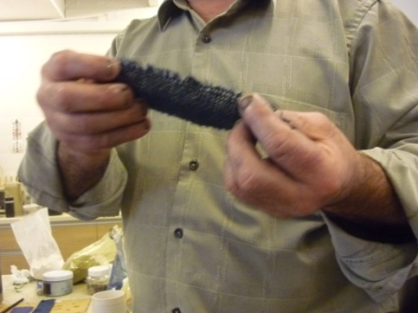indigo on wool and cotton samples
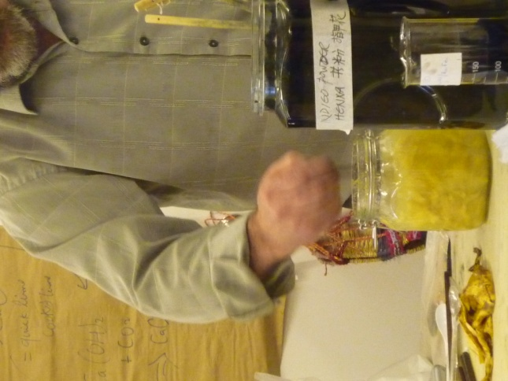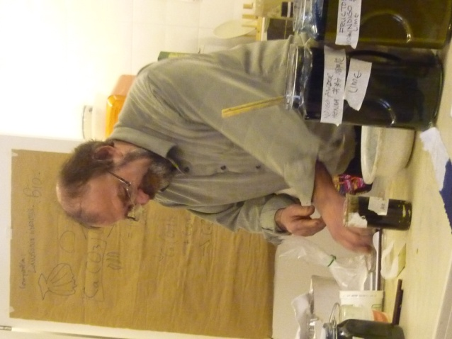
INDIGO TEST RESULTS
